Style Sheet for Submissions to eTropic

Overview of Style Rules

- Title [Georgia 16 point, bold, centred, title case]. Keep titles shorter.
- Author [Georgia 14 point, bold, centred]
- ORCID identifier under your name. See https://orcid.org/
- Affiliation and country [Georgia, 12 point, regular, centred].
- Abstract heading [Georgia 12, bold, centred]
- Abstract text [Arial 11, left-right indented, and left-right justified]
- Keywords: about 5 keywords [left justified], under the Abstract
- Headings for body of text [Arial 13 point, Title Case, bold, flush left]
- Headings spacing. 1 space before heading, 1 space after heading (1.15 line space)
- Subheadings [Arial 12 point, Title Case, bold, italic, 1 tab indent]
- Body Text: Arial 12 point, left-right justified
- Body Text: Line spacing 1.15
- Body Text: 1 line space for new paragraph (do not indent first line of paragraph)
- Images. Figure 1., Figure 2., etc. Written above image [Arial 10 point, bold]. Description/citation under image. [Arial 10 point, regular].
- Footnotes: Arial 9 point, regular
- Citations: In text citations (Author, date, page number). APA Edition 7.
- References [Heading, Arial 13 point, bold, flush left]
- References text [Arial, 11 point]; single spacing, flush left.
- References follow APA Edition 7.
- DOIs: references must include DOI (including the http) wherever possible. Look up correct DOIs using this very fast finder at Crossref Simple Text Entry page: https://apps.crossref.org/simpleTextQuery

See following sample below (note: the below sample shoud be used as a template, either start your essay in the template or cut and paste your essay into the template). Once your essay is complete simply remove the instructions on this first page, so this page becomes your title and abstract page. The information in the footer below remains and appears on your title page.

Title of Article: Keep it Concise (one to two lines only for your title)

Name of Author

University Affiliation, Country OR Independent Scholar/Artist, Country

Abstract

Text of abstract. Ariel 11 point, left-right indented, left-right justified. You can use the settings in the text here for your abstract. Cut and paste your abstract into this example. Note that abstracts are about 200-words long. New research indicates that readers prefer shorter amounts of text to read. Your abstract appears in indexes, so it should be readable, succinct and make sure it captures the points of your article.

Keywords: about 5 keywords, separated by a comma [ , ]. No more than 2 lines of keywords.

Note: in these technological times it is increasingly important to make sure that the wording of your title, abstract and keywords match up so your article can be found through online searches.

It is advisable to check archive issues of eTropic in order to understand the types of work the journal publishes, and also to visualize the style of the journal (more recent publications follow the updated style). The keyword cloud on the journal’s homepage is live, pressing a keyword will take you to lists of publications within that field.

Your essay/article begins on the next page after your Title and Abstract page. See below.

Headings: Use Title Case for Headings [Ariel 13 point, bold]

Text is Ariel 12 point, left-right justified. 1.15 spacing.

Example: Lorem ipsum dolor sit amet, ea per quod labores evertitur, magna percipit mei ne, libris ceteros forensibus usu ne. Cu est offendit legendos, mei id nemore rationibus. Eam aliquid ornatus commune ex. Eu has quem aliquid, eu eum idque deserunt.Vel partiendo maiestatis cu, no nam diceret accumsan, facer dignissim definitionem has cu. Melius sapientem ei mea. At pri ponderum perpetua, lorem essent id est, an diam prompta fierent eos. Mel nihil feugait mnesarchum ei, ne vim harum nonumy verear, no rebum nostro mea. Usu veniam nonumy admodum ei, ex mea accusam repudiandae, rebum soluta cu pro. Illum populo ornatus an nec, eos ferri vitae accumsan te, eu suas bonorum nam.

Subheadings [Ariel, 12 point, bold, italics]

Space under subheading is 12 point. Then text continues as normal (as in example below).

Usu eu illum atqui fastidii, sed mutat vocibus similique et, et qui tempor malorum deserunt. Pri ne omnis tractatos, lorem prompta scripserit eam no, ad porro libris vix. Ridens tacimates ei eum, cu graeco oporteat sea. Quando gloriatur vim cu. Usu utinam dolore te, in iudico aperiam has. Te mel suas nullam feugait, te quis oblique mei.

Quotes of more than 3 lines are left-right indented and left-right justified [As demonstrated here]. Arial 12 point. 1.15 spacing. Indented quotes do not require quotation marks. Quotes must be cited in brackets (Author, date, page). Follow APA (Edition 7) conventions.

After quote allow a space of 12 points and then continue text in Ariel 12 point font as previously. Quotes wihin text should use double quotation marks and must cite using author, date, page number system as set out in APA Edition 7. All quotes must exactly follow the wording of the author being quoted.

Images: Layout and Quality

Figure 1. Title in italics [Arial 10 point]

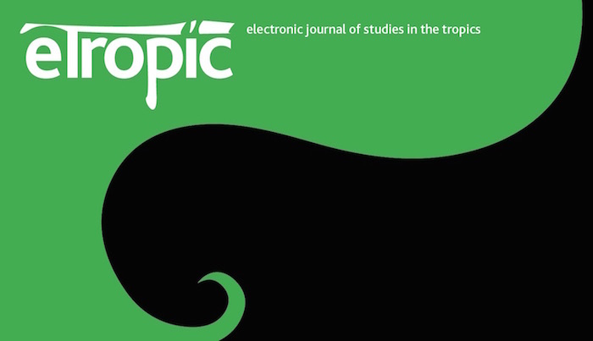

Description/Reference of the image (ie. Author, year, page number). Include in References.

Note for images. All images must be clear and well composed. They should not be too small or too large. Layout is important – images require enough white space surrounding them to make them aesthetic. (Consider, for instance, the layout size of indented quotes and the abstract). See example above of eTropic logo.

Illustrations, pictures, photographs and graphs, should be supplied in a high quality an electronic format. They should be placed in position in the text. Please follow the guidelines below.
- Format: TIFF, JPEG: Common format for pictures (containing no text or graphs).
EPS: Preferred format for graphs and line art (retains quality when enlarging/zooming in).

- Placement: Figures/charts and tables created in Word should be placed in the text in position. Figures and other files created outside Word (i.e. JPG, TIFF, EPS, PDF) should be placed in position in the text.

- Figure headings: Above image include Figure 1/Table 1 and title of image. (Ariel 10, Bold). Underneath the image/photo include Source information (Ariel 10, normal).
- Resolution: We recommend 150-220 ppi (pixels per inch). Note resolution refers to the density of pixels that make up the image or graph. The higher the resolution, he crisper the image. Lower resolution will be fuzzy and not acceptable. However, do not make the ppi too high as it will slow down download speed and also create difficulties in sending documents. DPI (Dots Per Inch) and PPI (Pixels per Inch) are not the same thing. DPI refers to a printed document and spacing of colour dots; PPI refers to Pixels on a screen.

For instance, the image of the eTropic logo (above) in pixels is: Width 800, Resolution (PPI Pixels per Inch) 150.

- Colour: Please note that images supplied in colour will be published in colour. Therefore, it is important that you supply images that are good colour quality.

- Dimension: Check that the artworks match the dimensions of the journal page. Images that are too small cannot be scaled up after origination.

- Fonts: The lettering used in any graph or table should not vary too much in size and font to the text of your article. (Use Ariel, 10 point or 9 point).

References

References begin on a clean page after the conclusion of your article.

Referencing system is APA Edition 7. It must be followed carefully.

List references in alphabetical order.

Use single line spacing, flush left, Ariel 11 point.

Example below:

Author, A.A. (year). Title of book. Publisher.

Author, A.A, & Author, B.B. (year). Title of chapter in edited book. In A. Editor, B. Editor, & C. Editor (Eds.), Title of edited book (chapter pages pp. xxx-xxx). Publisher.

Author, A.A, Author, B.B., & Author, C.C. (year). Title of journal article. Title of Academic Journal, Vol (issue), page numbers. doi:xx.xxxxxxxxxx

Director, B.B. (Director). (Year). Title of motion picture [Motion picture]. Studio production company.

Editor, A.A (Ed.). (year). Title of edited book. Publisher.

This is a useful link to APA: https://owl.purdue.edu/owl/research_and_citation/apa_style/apa_style_introduction.html

NOTE: eTropic does not follow the document layout specifics of APA, we only follow the citation and referencing style. (Use this style sheet as a template for your manuscript layout).

–––––––––––––––––––––––––––––––––––––––––––––––––––––––––––

Acknowledgements

Include acknowledgments here to funding bodies or to people who have helped you in the pathway of your article.

Author Bio. Your bio note should be about 100-150 words in length.

Note on Submission process: upload 2 copies of your Manuscript in your online Submission to eTropic. One copy labelled Author (and short title), which should include your name, university affiliation and your bio note + one copy labelled Anonymized (and short title) with your name, affiliation and bio details removed. (Both copies are loaded to the one Submission upload).

Footnotes, if used, are Arial 9 point. Single line spacing.

